Seafloor spreading

Mid-ocean ridge forms along a crack in the oceanic crust.
Molten material (magma or lava) comes out from the mantle.
As it comes out, the older rock is pushed to the side.
The lava cools and hardens forming new rock.
This process continues to repeat which spreads the ocean apart.
Because the seafloor is spreading apart, it drags some continents with it and pulls others. This is how the continents move around!!

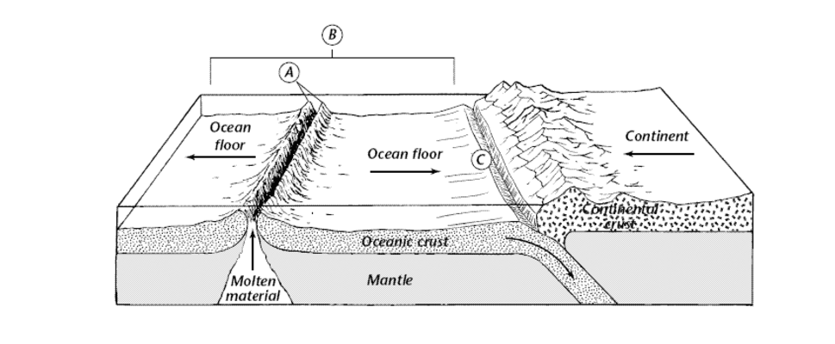
- Mid-ocean ridge
- The spreading seafloor
- The deep ocean trench is formed by the process of subduction

