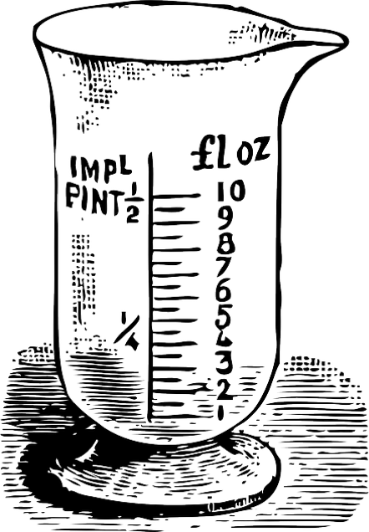
Measurement Lab
Name____________________________________

Date________________

Pd:________

Directions: Read through the directions at EVERY STATION. Complete the activities and make sure to include units (cm, mL).

Station 1: Measuring Volume Using Graduated Cylinders
Follow the instructions for measuring volume from your notebook. Read each graduated cylinder and record the amount below

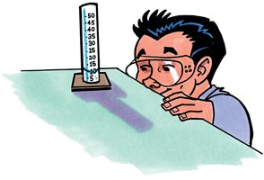
Graduated Cylinder A: _______________

Graduated Cylinder B: _______________

Graduated Cylinder C: _______________

Graduated Cylinder D: _______________

Station 2: Measuring Mass Using a Balance
Follow the instructions for measuring mass from your notebook. Round to the nearest whole number.
Rock:__________

Marker: __________________

Battery: __________________

Tape: __________________

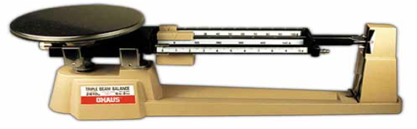

Station 3: Measuring Length Part 1
Follow the instructions for measuring length from your notebook. If you need to, use a pencil to mark the ends of each item on scratch paper and measure from one end to another.
Paperclip________________

Magnifying glass: _______________

Textbook length: _________width:_______height______

Spoon: ____________
